Five minutes with Belinda…
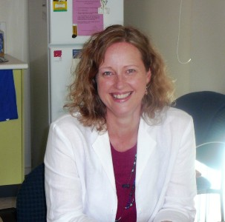

- How long have you worked at Karuna Maya?

I began working at Karuna Maya just over eleven years ago. At that time, I was looking for a place to set up myself in private practice. Initially I was looking to set up independently however I soon discovered that there was very little on offer in Torquay in the way of suitable office space. Just as well, as it lead me to looking for existing medical practices that may be interested in incorporating Allied Health as part of the services they offer. It was such good fortune that I discovered Karuna Maya. I remember my first meeting with Darren Fahroedin and how impressed I was with his perspective on a holistic approach to health. Luckily for me Darren also saw something in me that he felt made a good match and he invited me to join what was colloquially known as “The Tree People”. Reflecting on the past eleven years I feel it is where I was meant to be and I greatly appreciate the opportunity I have had to be of service to and to be a part of, the wonderful community that is the Surf Coast.

- Tell us something about yourself that we don’t know.
A little-known fact about me is that I am the direct descendent of two Irish convicts who were transported to Australia in the mid 1800’s. My forbearer Catherine Foley was transported to Australia in 1836 on the ship the Pyramus, for the crime of stealing a cloak. Four years later John Brannigan was transported on the ship Middlesex, on the charge of stealing firearms. Somehow and against all the odds, they served their time, met and bought six children into the world. Theirs is a story of tenacity and will to survive in the harshest of circumstance. I draw strength from knowing that part of my DNA comes from two people who showed such great courage and persistence in the face of hardship.

- What is your philosophy of life?
In a word compassion: for my fellow beings who share this wonderful world of ours. Living this brings with it many challenges as I am faced with the reality that the peoples of this world do not always act with compassion. Rather than use this as a reason for withdrawing into self-interest, I choose instead to continue to operate with all the wonder and optimism I had as a child. At times, this leads to me feeling heartbroken but for me I would rather this than closing off my heart and run the risk of becoming hard hearted.

- What are your hobbies?
Eighteen months ago, a bought a 100-year-old house in need of lots of TLC. So, these days my hobby is restoring her to her once former glory. This includes re-establishing a garden, filled with all my sentimental favourites gathered from the gardens of my grandmother, mother, family and friends. I take great delight spending time tending the plants that I remember once grew in the gardens of those that I love. I have also taken great delight in seeing the birds return to my garden as I add plants which provide them food and shelter.

- Where do you like to take vacations?
Since buying my project house, most of my free time is spent on the garden and on the house renovations. I dream of the time when I can travel further afield and one day I plan to visit Canada to see the Northern Lights and Ireland to visit the home of my forbearers and attend the Glastonbury music festival.

