5 Questions with Caroline Chee

How long have you worked at KMM & what do you like best about working at KMM?

I have worked at KMM since July 2009!!
The people!! I love the people I work with - an incredible group of open-minded practitioners, with a common commitment to helping their patients; the people who run the clinic day to day, including our front desk staff, and all the ones behind the scenes, and of course the people who come to the clinic - they make it!
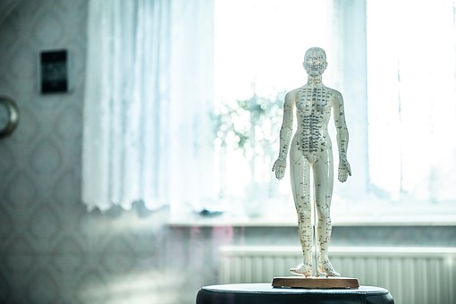

What do you enjoy most about your job?
Hahaha.. See above answer!
I see it as a huge privilege to work as an osteopath. The trust that my patients place in me is something I take very seriously. I love being able to help them. To help them understand their bodies, their pain, the health care system, and themselves better.

How do you like to spend your Xmas break?
With my daughter! We love hanging out with my family for the Christmas break – eating and indulging and playing. We also love our pre-Christmas camping trip with our coastal ‘family’ which also involves eating, indulging and playing... And the odd surf too!

What did you want to be when you were younger??
A detective, an historian, a builder, and an archaeologist all spent time at the top of my list!

Favourite meal?
Hmmmm… That is like choosing your favourite child, but maybe Curry Laksa.

