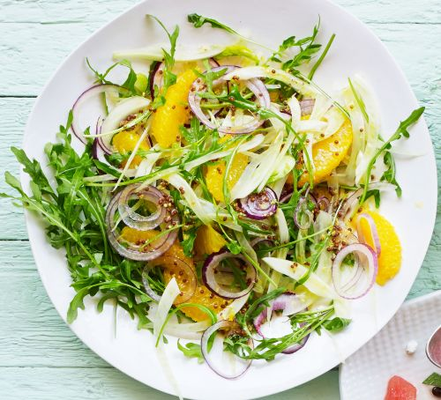
Orange and Fennel Salad

INGREDIENTS
4 oranges
2 small (600g) fennel bulbs, trimmed, sliced
1 medium red onion, thinly sliced
1/4 cup loosely packed Italian parsley leaves
ORANGE VINAIGRETTE
100mls olive oil
80mls (1/3 cup) fresh orange juice
1 teaspoon wholegrain mustard
Salt & ground black pepper
METHOD
Step 1 Finely grate the rind from 1 orange and reserve. Peel and segment all oranges.
Step 2 To make the orange vinaigrette mix the reserved orange and with the olive oil, orange juice, mustard and salt and pepper to taste in a screw-top jar. Shake well.
Step 3 Toss the orange segments with the fennel and red onion in a bowl to combine. Place on a serving plate or in a serving bowl, sprinkle with the parsley and pour over the orange vinaigrette.

